**Created with an evaluation copy of Aspose.Words. To remove all limitations, you can use Free Temporary License** [**https://products.aspose.com/words/temporary-license/**](https://products.aspose.com/words/temporary-license/)



Git: Branches, Merges, and Remotes



Course completed by Diwas Adhikari

May 15, 2024 at 04:39AM UTC • 3 hours 3 minutes

Top skills covered

Git



Head of Content Strategy, Learning

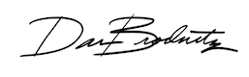

Certificate ID: e31237ae7f3177e12f0782e207e0f7b8fe73f077e6801e776a2fac74442578b6